**Analyzing Chinese Restaurants in Lagos Nigeria**

**Ijegwa David Acheme**

[**acheme.david@edouniversity.edu.ng**](mailto:acheme.david@edouniversity.edu.ng)

**Introduction**

In this project, I will be Analyzing a popular Hotel in Lagos, Nigeria. In recent years, Business Relationship between Nigeria and China has been growing with Chinese companies and expertrites taking over majority of infrastructural works in Africa's biggest economy. This has led to the influx of Chinese in high proportions to Nigeria leading to demands in Chinese foods and restaurants. In this work I intend to use the foursquare location data to explore Chinese restaurants in Lagos which is the commercial center of Nigeria so as to provide recommendation. This work will demonstrate in details how to make calls to the Foursquare API, construct a URL to send a request to the API to search for a specific type of venues and to explore a particular venue, geographical location, and to get trending venues around a location. I will also, show how to use the visualization library, Folium, to visualize the results.

**Lagos**, was until 1991 the capital of Nigeria, it has however, remained the unofficial seat of many government agencies, the largest city in Nigeria and has the biggest economy. The city’s population is centered on Lagos Island, in Lagos Lagoon, on the Bight of Benin in the Gulf of Guinea. Lagos is Nigeria’s largest city and one of the largest in sub-Saharan Africa.

**1.2 The Problem**

The population of Chinese in Nigeria is increasingly growing, this is as a result of the growing trade relationship between both countries, currently all the major infrastructural works raging from railways, roads and power plants are handled by the expertise. With their presence comes also the need for their delicacies. In this work we intend to explore Chinese restaurants around one of the most popular hotels in Lagos and rank them based on user ratings so that we can make recommendations.

**DATA**

The data set we shall be utilizing for this work is retrieved from the foursquare location data provider API, it consists of the restaurant name, category, address, distance from the chosen hotel and id. This data is retrieved a JSON file and this is converted into a pandas data frame as shown in figure 1.

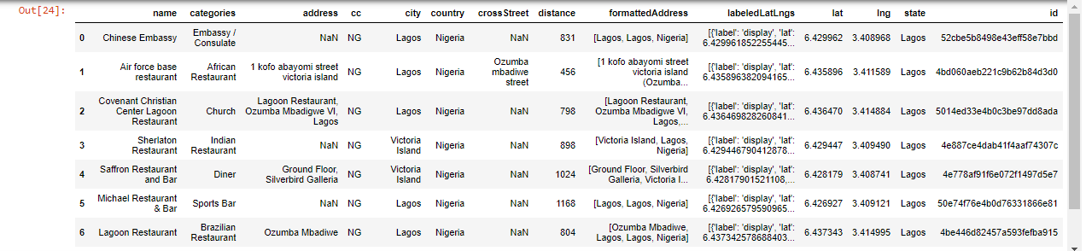

Figure 1: Location data in the Neighborhood of Federal Palace Hotel, Lagos

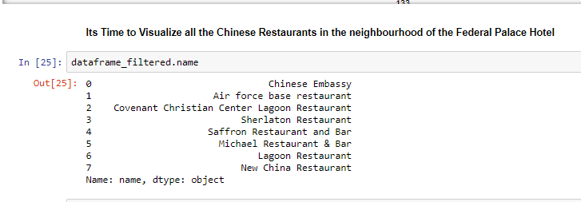

Figure 2, is a summary of the Chinese restaurants in the neighborhood of the federal palace hotel

**Methodology**

From the foursquare’s API data, which were translated into a pandas data frame, we carried out the following exploratory analysis.

1. Visualization of all the Chinese restaurants in the neighborhood of the Federal Palace Hotel
2. Exploration of each of the restaurants within the neighborhood to find the users’ ratings
3. Exploration of the closest restaurant and the restaurant with the highest ratings to find the trending venues around it

**Results:**

In this result section I present the findings defined in the methodology section

**Visualization of all the Chinese restaurants in the neighborhood of the Federal Palace Hotel**

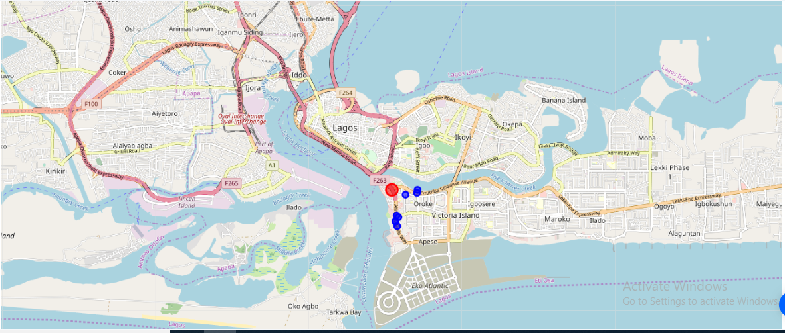

**Figure: 3 Map of Lagos Showing the Federal Palace Hotel and Neighboring Chinese Restaurants.**

From figure 2, we further explore the following restaurants; Airforce base Restaurant, New China Restaurant, and Saffron Restaurant. This is to enable us determine their user ratings and rank them accordingly, the results of this is shown in figures 4-6

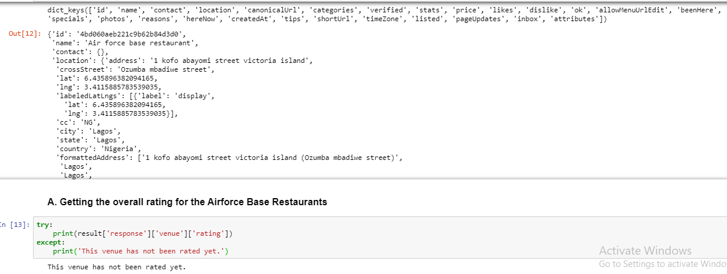

Figure 4: Checking the overall rating for the Airforce Base Restaurant

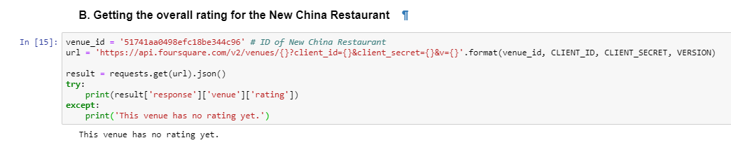

Figure 5: Checking the overall rating for the New China Restaurant

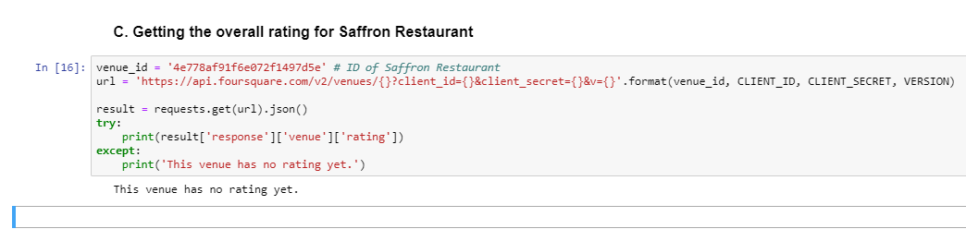

Figure 6: Checking the overall rating for Saffron Restaurant

**Exploration of Popular and Trending Venues around the Federal Palace Hotel**

I further sought to find out the most popular venues around the hotel, using the foursquare API we obtained the JSON file containing this information and converted it into a pandas dataframe. Then using the folium library, I show a Map of the popular locations around the federal palace hotel. Figure 7.

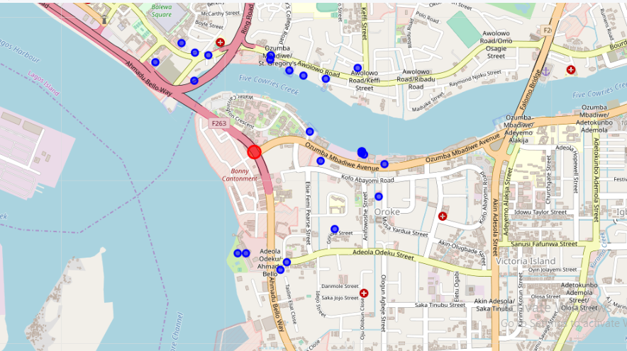

**Discussion**

From the exploration and analysis of the location data of the Chinese restaurants in the neighborhood of the federal palace hotel, one of the foremost hotels in Nigeria’s commercial center, Lagos, we found that there are upto five restaurants that offer Chinese foods within its neighborhood. However the main goal of this project which was to rank these restaurants based on user ratings was not achieved as the available data from foursquare API showed that there are zero ratings for all the hotels.

Conclusion

In this project I set out to explore Chinese restaurants around a foremost Nigerian Hotel and to rank them based on user ratings. This would have presented an evidence based recommendation data to people desirous of Chinese delicacies within that neighborhood. However available data showed that there are zero ratings for this restaurants. One of two factors might be responsible for this; the restaurants have no online presence or the foursquare location data provider needs to update their database.